LABORATORY RECORD
Course | Full Stack Web Development | Date | 22-09-2026
Course Code | 23CM4121 | Exp. No. | 5
Student Name | Badana Pranathi | Roll No. | A24126552071

1. TITLE
Design and Implementation of a Dynamic To-Do List Application Using JavaScript DOM Manipulation and Event Handling

2. AIM
To develop a To-Do List web application that allows a user to add tasks, mark them as complete, and delete them, using JavaScript to dynamically create, update and remove DOM elements, with an empty-state message shown when no tasks remain.

3. OBJECTIVE
The objectives of this experiment are:
- To design a form with a text input and an Add Task button for capturing new tasks.
- To validate the input so that empty tasks cannot be added.
- To dynamically create list items containing task text, a Complete button, and a Delete button using createElement and appendChild.
- To toggle a 'completed' CSS class on a task using classList.toggle() to visually mark it as done.
- To remove a task from the DOM using element.remove() when its Delete button is clicked.
- To show or hide an 'empty list' message based on the number of remaining tasks.
- To style the application using Flexbox, box-shadow and border-radius for a clean card-based interface.

4. THEORY
A To-Do List is a classic example of dynamic DOM manipulation in JavaScript. Rather than writing static HTML for each task, the page starts with an empty <ul>, and JavaScript builds new <li> elements at runtime using document.createElement(), populates them with createElement/textContent, and inserts them into the page with appendChild(). Event listeners attached to dynamically created buttons (Complete, Delete) allow each task to respond independently to user interaction. The classList.toggle() method provides a concise way to switch a CSS class on and off, which is used here to apply and remove a strike-through style. Removing an element with element.remove() and tracking taskList.children.length allows the application to detect when the list becomes empty and show appropriate feedback to the user.
Application Flow: Enter Task -> Validate Input -> Create <li> with Text, Complete & Delete Buttons -> Append to List -> Toggle Complete / Remove on Delete -> Update Empty-List Message

5. ALGORITHM / PROCEDURE
- Create index.html with a container holding a heading, a text input (#taskInput), an Add Task button (#addBtn), an empty <ul> (#taskList), and an empty-state paragraph (#emptyMessage); link style.css and script.js.
- In script.js, select taskInput, addBtn, taskList and emptyMessage using getElementById.
- Attach a click event listener to addBtn. Inside it, read and trim the value of taskInput.
- If the trimmed value is empty, show an alert and return without adding a task.
- Otherwise, create a new <li>, a <span> for the task text, and Complete/Delete <button> elements; set their text content and CSS classes.
- Append the span and both buttons to the <li>, then append the <li> to taskList.
- Attach a click listener to the Complete button that toggles the 'completed' class on the task's span, producing a strike-through effect.
- Attach a click listener to the Delete button that removes the <li> from the DOM and calls checkEmptyList().
- Clear the input box and hide the empty message after a task is successfully added.
- Define checkEmptyList() to show #emptyMessage when taskList has zero children, and hide it otherwise.
- Style the page in style.css using Flexbox centring, a card container, and colour-coded Add/Complete/Delete buttons.
- Test the application: adding tasks, completing tasks, deleting tasks, and confirming the empty-list message behaviour.

6. PROGRAM
index.html
<!DOCTYPE html>
<html>
<head>
<title>My To-Do List</title>

<!-- Linking CSS file -->
<link rel="stylesheet" href="style.css">
</head>

<body>

<div class="container">

<!-- Heading -->
<h1>My To-Do List</h1>

<!-- Text box to enter a task -->
<input type="text" id="taskInput" placeholder="Enter a task">

<!-- Button to add the task -->
<button id="addBtn">Add Task</button>

<!-- Empty list where tasks will be added dynamically -->
<ul id="taskList"></ul>

<!-- Message shown when there are no tasks -->
<p id="emptyMessage">No tasks available.</p>

</div>

<!-- Linking JavaScript file -->
<script src="script.js"></script>

</body>
</html>

script.js
// Select the input box using its ID
const taskInput = document.getElementById("taskInput");

// Select the Add Task button
const addBtn = document.getElementById("addBtn");

// Select the <ul> where tasks will be added
const taskList = document.getElementById("taskList");

// Select the message that says "No tasks available"
const emptyMessage = document.getElementById("emptyMessage");

// Add an event listener to the Add Task button
// This function runs whenever the button is clicked
addBtn.addEventListener("click", function () {

// Get the value entered by the user
const task = taskInput.value.trim();

// Check if the input box is empty
if (task === "") {
alert("Please enter a task.");
return;
}

// Create a new <li> element
// This will represent one task
const li = document.createElement("li");

// Create a <span> element for the task text
const taskText = document.createElement("span");

// Put the entered task inside the span
taskText.textContent = task;

// Add a class to the span
taskText.className = "taskText";

// Create the Complete button
const completeBtn = document.createElement("button");

// Set button text
completeBtn.textContent = "Complete";

// Add CSS class
completeBtn.className = "completeBtn";

// Create the Delete button
const deleteBtn = document.createElement("button");

// Set button text
deleteBtn.textContent = "Delete";

// Add CSS class
deleteBtn.className = "deleteBtn";

// Add the task text to the <li>
li.appendChild(taskText);

// Add Complete button to the <li>
li.appendChild(completeBtn);

// Add Delete button to the <li>
li.appendChild(deleteBtn);

// Add the complete task to the task list
taskList.appendChild(li);

// Add event listener to Complete button
completeBtn.addEventListener("click", function () {

// Add or remove the "completed" CSS class
// This creates the line-through effect
taskText.classList.toggle("completed");

});

// Add event listener to Delete button
deleteBtn.addEventListener("click", function () {

// Remove the complete <li> element from the list
li.remove();

// Check whether there are any tasks left
checkEmptyList();

});

// Clear the input box after adding the task
taskInput.value = "";

// Hide the "No tasks available" message
emptyMessage.style.display = "none";

});

// Function to check whether the task list is empty
function checkEmptyList() {

// If there are no <li> elements
if (taskList.children.length === 0) {

// Show the empty message
emptyMessage.style.display = "block";

} else {

// Hide the empty message
emptyMessage.style.display = "none";
}
}

style.css
/* Basic page styling */
body {
font-family: Arial, sans-serif;
background-color: #f2f2f2;
display: flex;
justify-content: center;
align-items: center;
min-height: 100vh;
}

/* Main container */
.container {
width: 500px;
background-color: white;
padding: 30px;
border-radius: 10px;
box-shadow: 0 0 10px gray;
}

/* Heading */
h1 {
text-align: center;
}

/* Text box */
input {
width: 65%;
padding: 10px;
border: 1px solid #ccc;
border-radius: 5px;
}

/* Add Task button */
#addBtn {
padding: 10px 15px;
background-color: green;
color: white;
border: none;
border-radius: 5px;
cursor: pointer;
}

/* Each task */
li {
list-style: none;
margin: 10px 0;
padding: 10px;
background-color: #eeeeee;
border-radius: 5px;
display: flex;
align-items: center;
gap: 10px;
}

/* Task text takes available space */
.taskText {
flex: 1;
}

/* Complete button */
.completeBtn {
background-color: blue;
color: white;
border: none;
padding: 7px 10px;
border-radius: 4px;
cursor: pointer;
}

/* Delete button */
.deleteBtn {
background-color: red;
color: white;
border: none;
padding: 7px 10px;
border-radius: 4px;
cursor: pointer;
}

/* Style applied when task is completed */
.completed {
text-decoration: line-through;
color: gray;
}

7. CODE EXPLANATION
Code / Syntax | Explanation
document.getElementById(id) | Selects the task input box, Add Task button, the <ul> task list, and the empty-list message paragraph.
addBtn.addEventListener("click", ...) | Runs the add-task logic every time the Add Task button is clicked.
taskInput.value.trim() | Reads the text typed by the user and removes leading/trailing whitespace before validation.
if (task === "") { alert(...); return; } | Prevents empty tasks from being added by alerting the user and exiting the handler.
document.createElement("li"/"span"/"button") | Dynamically builds a list item containing a text span, a Complete button, and a Delete button for each task.
element.textContent / element.className | Sets the visible text of each element and assigns a CSS class for styling.
li.appendChild(...) / taskList.appendChild(li) | Assembles the task's span and buttons inside the <li>, then adds the completed <li> to the task list.
completeBtn.addEventListener("click", ...) | Toggles the 'completed' class on the task text, producing the strike-through styling.
classList.toggle("completed") | Adds the completed class if absent, or removes it if present, allowing a task to be marked done or undone.
deleteBtn.addEventListener("click", ...) | Removes the entire task <li> from the page when Delete is clicked, then calls checkEmptyList().
li.remove() | Deletes the task's list item element directly from the DOM.
checkEmptyList() | Shows the 'No tasks available.' message when the list has zero <li> children, and hides it otherwise.
taskInput.value = "" | Clears the input box after a task has been successfully added.
.container { box-shadow; border-radius } | Gives the to-do card a centred, rounded, shadowed appearance using Flexbox centring on the body.
li { display:flex; align-items:center; gap } | Lays out each task's text and its two buttons in a single row with even spacing.
.completed { text-decoration: line-through } | Visually strikes through and greys out a task's text once marked complete.

8. TEST CASES AND EXECUTION DATA
The experiment was executed with the following test cases to verify functionality:
Test Case | Input / Action | Expected Result | Actual Result | Status
TC-01 | Click Add Task with the input box empty | An alert reads "Please enter a task." and no list item is added | Alert displayed; task list unchanged | Pass
TC-02 | Type a task and click Add Task | A new list item appears showing the task text, a Complete button, and a Delete button; input box clears | Task added correctly, input cleared | Pass
TC-03 | Add multiple tasks in sequence | Each task appears as a separate list item in the order added | All tasks listed correctly | Pass
TC-04 | Click Complete on a task | The task text becomes strike-through and greyed out | 'completed' class toggled; strike-through applied | Pass
TC-05 | Click Complete on the same task again | The strike-through is removed, restoring normal text | classList.toggle() reverses the completed state | Pass
TC-06 | Click Delete on a task | That task's list item is removed from the page immediately | li.remove() deletes the item from the DOM | Pass
TC-07 | Delete all tasks from the list | The "No tasks available." message reappears once the list is empty | checkEmptyList() shows the message when taskList.children.length is 0 | Pass
TC-08 | Add a task after the list was emptied | The empty message hides again and the new task is shown | emptyMessage.style.display set to 'none' on add | Pass

9. OUTPUT
Output: To-Do List Application - Rendered in Browser
Output 1 - Initial State (No Tasks Added)
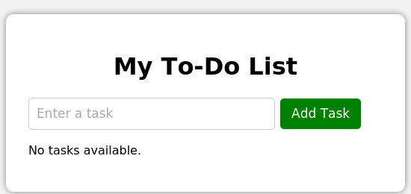
Output 2 - Tasks Added, with the First Task Marked Complete
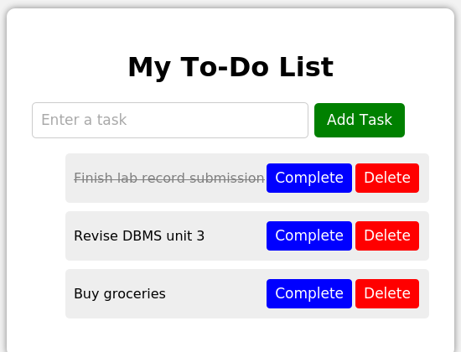

10. RESULT
Thus, the To-Do List web application demonstrating dynamic DOM element creation, event handling, task completion toggling, task deletion, and empty-state messaging was successfully designed, implemented, and verified.

